ARTICLE TITLE (TNR, 12pt Bold)

Budi Sumargono¹, Cecep Badarudin², Deden Andara³ and This is my name here² (TNR, 10pt Bold)
¹Faculty, University / institution, Jalan Dr. Setiabudi No.229 (TNR, 10pt Normal)
²My affiliation is written here, This is my affiliated address written here
E-mail: xxxxx@email.com; writer2@email.com; author3@email.com; writer3@email.com

ABSTRACT (10pt Bold)
Abstracts must be written in one-spaced paragraphs, containing a maximum of 250 words, and written in Times New Roman 10 pt. Abstracts must be written in Indonesian and English. The abstract must include research objectives, methods (participant characteristics, population, samples, sampling methods, data collection, and data analysis), findings, and conclusions. If necessary, recommendations can be given at the end of the paragraph. After the abstract, provide five keywords separated by semicolons (;). Choose keywords carefully that allow search engines to find your article.

Key words: author's guidelines; sosiohumaniora; Unpad; template

INTRODUCTION
In the introduction, the author must discuss the purpose of the study at the end of the introduction. Before describing the purpose of the study, the author must describe the background, initial literature study (state of the art) as the basis for "gap analysis" which discusses the novelty of scientific research from articles, research, and hypotheses (if any). In the introduction there is nothing included in the separate literature in the headings agreed in the research report, which is written in the translation described behind in the research which discusses the literature that can show the state of the art - or the novelty of scientific discovery.

METHOD
The methods section provides an explanation of the types of research / research designs. This section explains the number of subjects and the characteristics of the subject demographic data collection (Azwar, 2007). In quantitative research, if the research uses certain measuring instruments, it is necessary to convey the name of the measuring instrument, the number of items, the reliability coefficient, and the data analysis method used. In qualitative research, qualitative perspectives are used, and methods of data collection and analysis are discussed (Willig, 2008).

RESULTS AND DISCUSSION
The results and discussion contain the results of research findings and scientific discussions. Write down scientific findings (scientific findings) obtained from the results of research conducted but must be supported by adequate data. The scientific findings agreed here are not the research data obtained. What scientific findings were obtained? Why did it happen? Why is the trend variable like that? All of these questions must be discussed scientifically, not just descriptive, and supported by adequate empirical data. In addition, the comparison must also be compared with the results of other researchers who are almost the same topic. Research results and findings must be able to answer hypotheses and / or research questions in the introduction.
Tables (maximum of 6 tables) and Figures (maximum of 6 figures) are placed in groups of text after the tables or figures are referred. Each image must be given the title of the image below this image and numbered. Each table must be given a table title and numbered sequentially to the top of the table followed by the source of the table.
The images must be agreed to be written clearly (font size, resolution and line size must be sure to print clearly consisting of JPEG). Image groups consist of diagrams / rules, tables and are released according to columns of text groups or if they are too large placed in the middle of the page. Tables should not contain vertical lines, horizontal lines are permitted but only important ones.

NOTED: MAXIMUM 6 TABLES AND FIGURES

Table 1. Correlations between Variables
Aspects of Family Support | Work Stress
 | r | p
Emotional support | 0,167 | ………….
Support award | 0,255 | .…………
Support counsel | 0,285 | …………..
Instrument of support | …… | ….……….
(Source: ...........................................)

Note: Write down the value of p (not p <0.05 or p <0.001) unless the results of the analysis show p = 0,000 then it must be written as p <0.001; or if accepted p = 1,000, it must be written as p> 0.99. To facilitate significance, a ** can be added for p values ​​<0.001 and * for p values ​​<0.05.
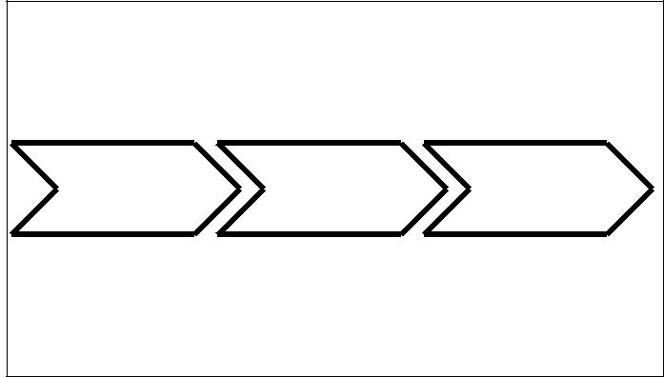

Figure 1. Research Procedure

CONCLUSION
The Conclusions section consists of only one paragraph but obtained answers from hypotheses and / or research objectives or scientific findings obtained. Conclusions are not the result of repetition of the results and discussion, but more than the results of the results as expected from the results of the study. If necessary, at the end can be written things that will be done related to further research from the research.

ACKNOWLEDGMENTS (if any)
The thank you section (if any) is mainly directed at research funders or donors and those who assist with the implementation of research whose contribution is not significant enough to be included in the authorship group.

REFERENCES
The bibliography section must contain all references cited / cited in the article text must be included in the Bibliography section. Bibliography must contain reference libraries originating from primary sources (scientific journals; minimum 80%) of the total bibliography) published in the last 10 (ten) years. The number of references cited at least 20 (twenty) library sources. Writing a citation or citation is recommended to use a reference management application program for example: Mendeley, Turnitin, Grammarly, EndNote, Zotero, or others. Follow the author instructions in the APA Style (The American Psychological Association).

Library in the form of scientific magazines/ journals:
Diab, A., Abdelazim, S. I., & Metwally, A. B. M. (2023). The impact of institutional ownership on the value relevance of accounting information: Evidence from Egypt. Journal of Financial Reporting and Accounting, 21(3), 509-525.
Karamanou, I., and Vafeas, N. (2016). The association between corporate boards, audit committees, and management earnings forecasts: An empirical analysis. Journal of Accounting Research, 43(3), 453–486.
Agustinus. W. (2016) Kerangka Ekonomo Makro Daerah Kota Bitung di Kawasan Pengem-bangan Ekonomi Terpadu. Sosiohumaniora, 18, 185-190.
Shintadewi, E.A & Sumartias S. (2017). Promosi Kesehatan Hiv-Aids dan Stigma Terhadap Pengguna Narkoba Suntik (Penasun) di Kabupaten Sumedang. Sosiohumaniora, 19, (2), 129-140.
Nugrahanto, W. & Adyawardhina, R. (2018). Demokrasi Dalam Sejarah Militer Indonesia; Kajian Histois Tentang Pemilihan Panglima Tentara Pertama Tahun 1945. Sosio-humaniora, 20, (2), 78-85. doi: https:// doi.org/10.24198/sosiohumaniora.v20i1.14368

Library in the form of book titles:
Azwar, S . (2007). Metode penelitian. Yogyakarta: Pustaka Pelajar.
Lunsford, A., & Ede, L. (2009). Child education: Perspective on teaching activities. Carbondale: Illinois University Press.
Willig, C. (2008). Introducing qualitative research in psychology: adventures in theory and method. (2nd ed.). London: McGraw-Hill Open University Press

Library in the form of Seminar Proceedings:
Desiningrum, D. R. (2011). Future time perspective, goal orientation, and subjective well being in elderly. The Padjadjaran International Conference on Psychology (pp.17-23). Bandung, Indonesia: Faculty of Psychology, Padjadjaran University.

Library in the form of a dissertation / thesis / thesis:
Pratama, A. G. (2009). Kontribusi kesejahteraan subjektif pada religiusitas Islam, persepsi tentang penyakit, dan perilaku menjaga kesehatan diri dalam model perilaku meme-lihara kesehatan: Suatu upaya menemukan model perilaku memelihara kesehatan dengan taraf kecocokan optimal pada penderita HIV+. Disertasi. Program Pasca sarjana Universitas Padjadjaran Bandung.

Library in the form of a Handbook:
Albarracin, Johnson, & Zanna. (2005). The handbook of attitudes. New Jersey: Erlbaum.
American Psychological Association. (2010). Publication manual of the American Psychological Association. Sixth edition. Washington D.C.: American Psychological Association

