STAGES OF ONLINE REGISTRATION AS A PRESENTER ON THE ICEBEF SITE IN 2024
No | TAHAPAN
1 | Website Access: login access  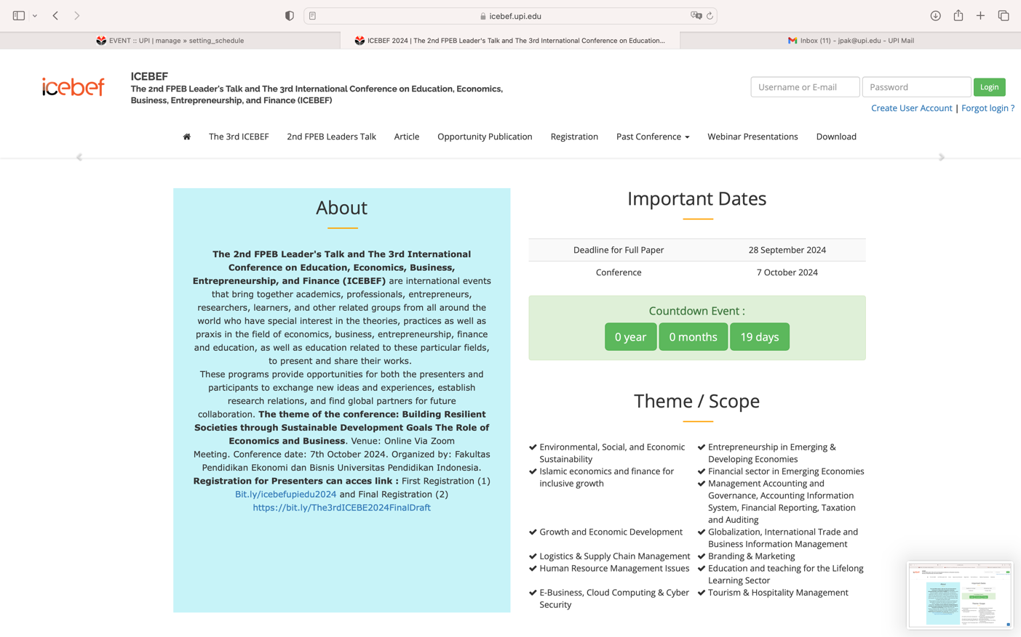
2 | Create an Account on the Right Side  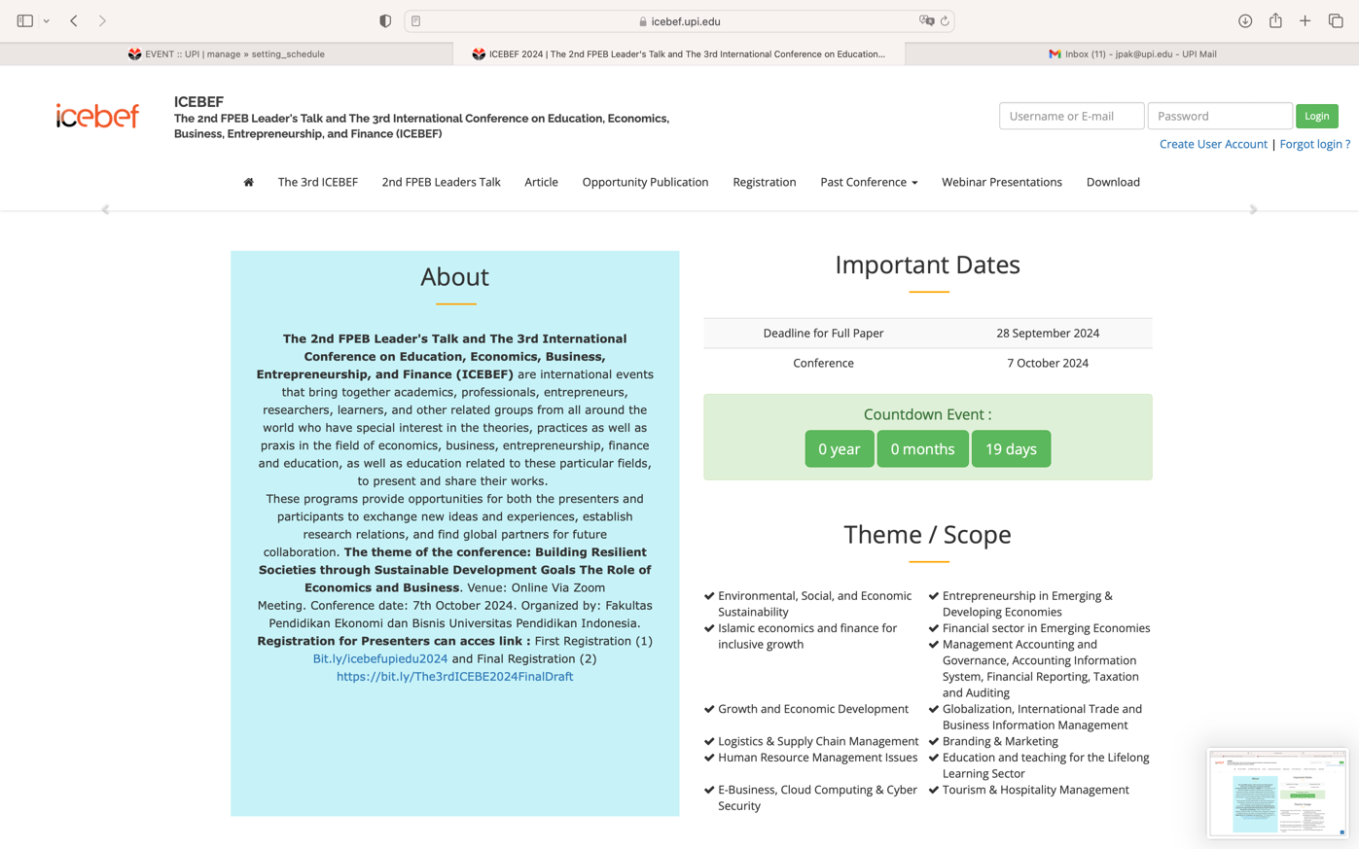
3 | Fill in the data and create a username and password  Username and password must be saved (if you forget to save your username and password, you can use the forgot password menu by verifying via email for the latest password)  Then finish by pressing the SEND menu at the bottom  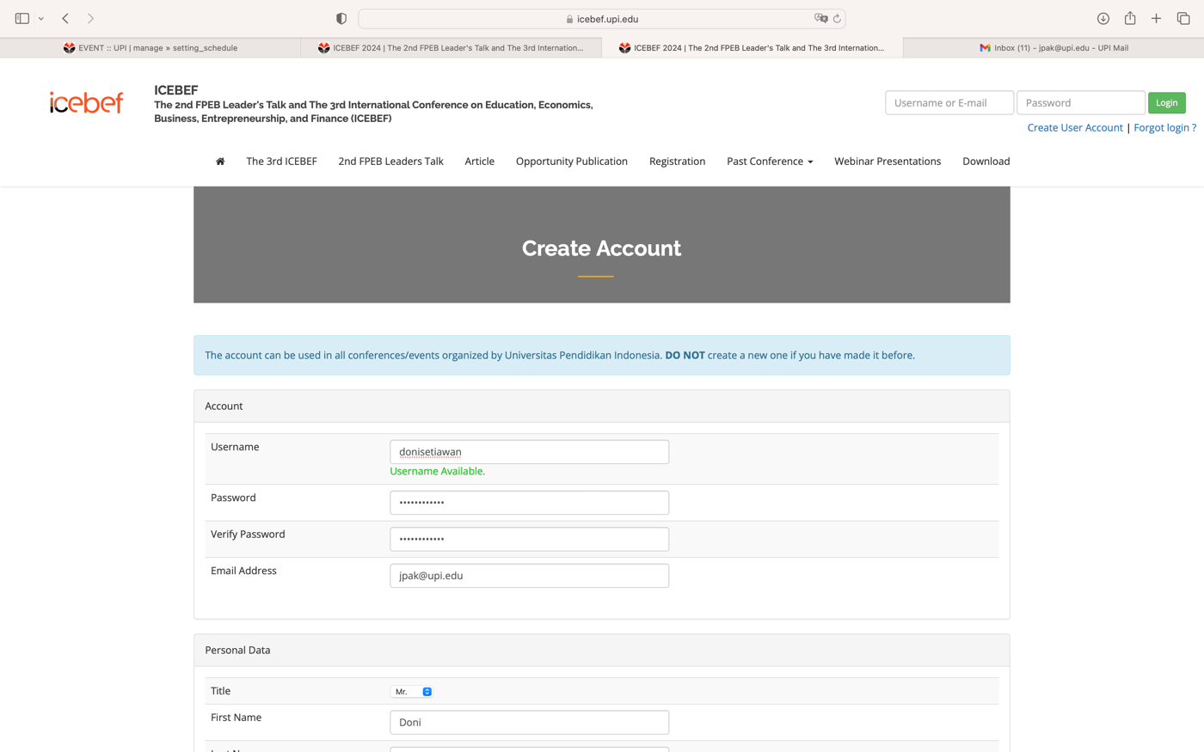  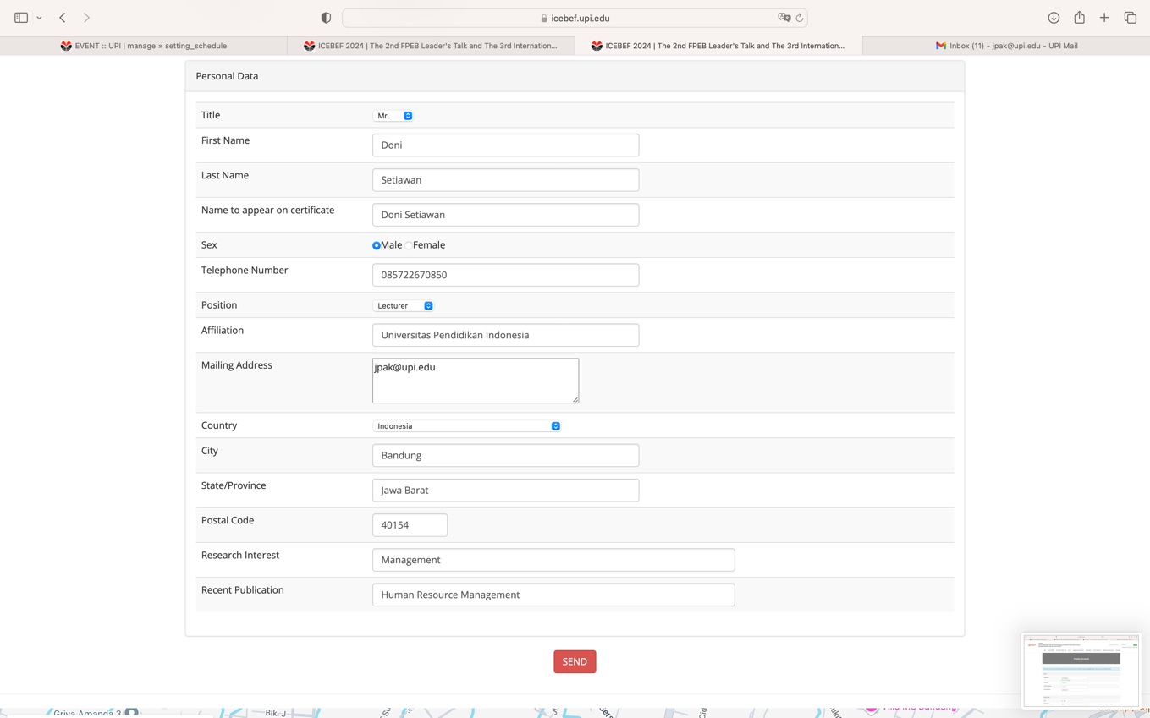
4 | After selecting the SEND menu button, information will appear that your registration has been successful. Next, you can log in and proceed to the next stage to send (upload) the Abstract  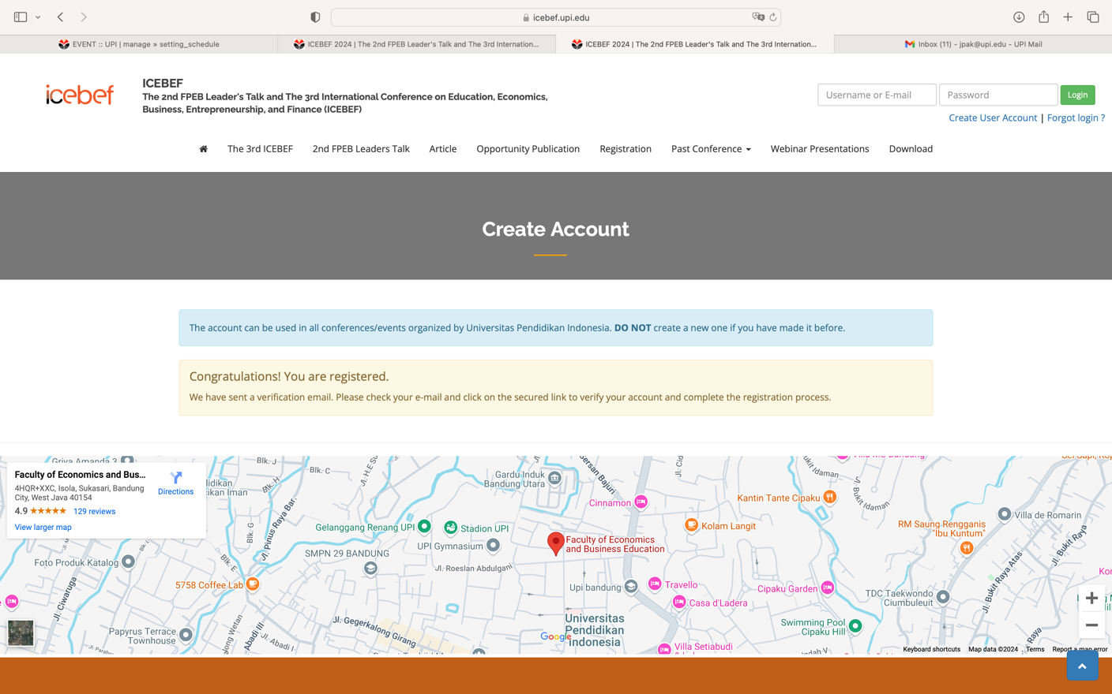
5 | To become a presenter, you select a presenter  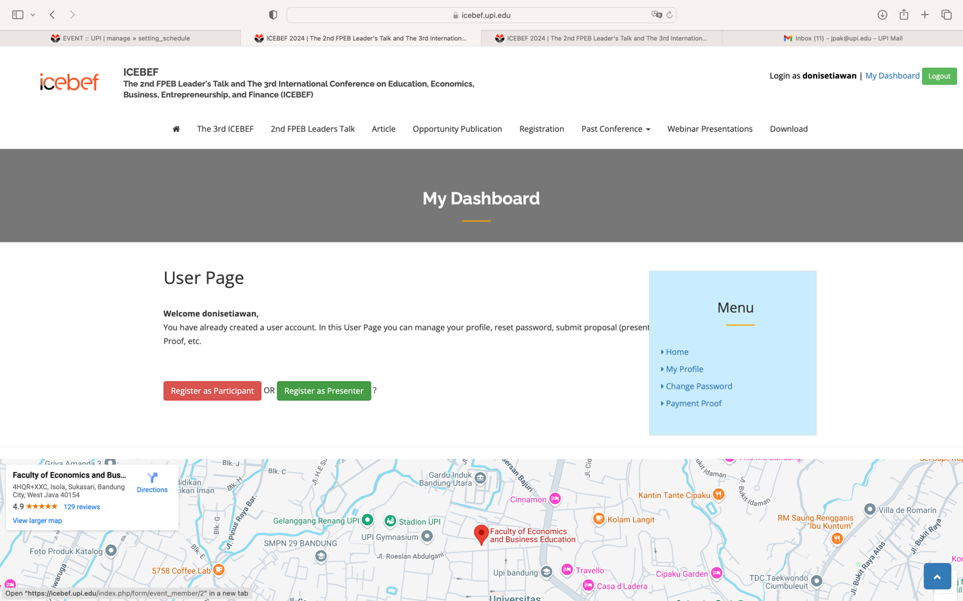
6 | Untuk mengirimkan abstrak dan artikel pilih menu bagian abstrak pada bagian kanan bawah  Fill in the article abstract data  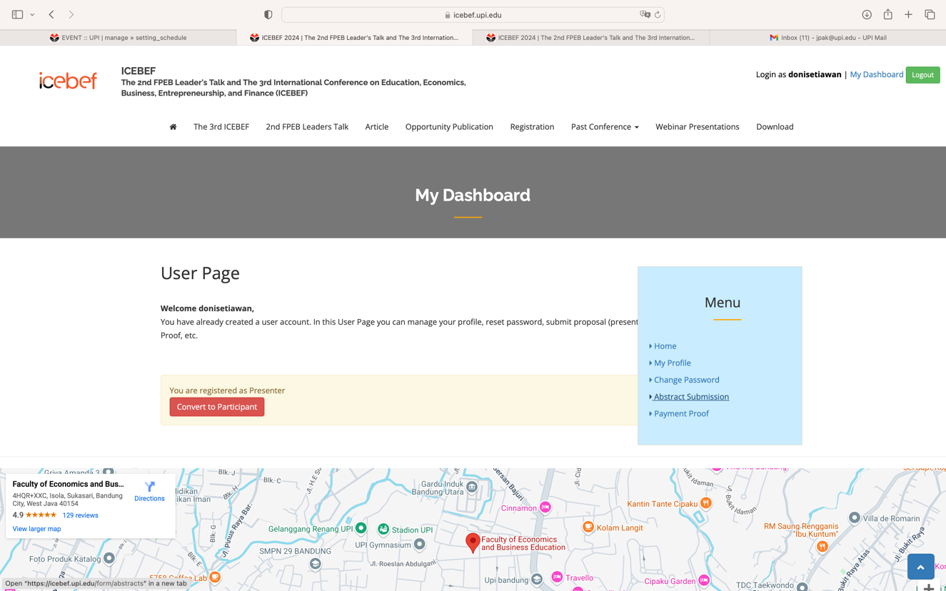
7 | After the abstract is received, you can continue to download the LOA, upload proof of payment and send (upload full article)  